TRANSCRIPTION
The Bacterial Transformation
It involves three processes
- Initiation, in which the transcription apparatus assembles on the promoter and begins the synthesis of RNA;
2. Elongation, in which RNA polymerase moves along the DNA, unwinding it and adding new nucleotides, one at a time, to the 3 end of the growing RNA strand; a
3. Termination, the recognition of the end of the transcription unit and the separation of the RNA molecule from the DNA template.
As we know that for transcription to initiate, RNA polymerase must bind to promoter region of the gene.
Genetic information on chromosomes is organized into transcription units. These are segments of DNA that are transcribed into a single RNA molecule. Each transcription unit is bounded by sites where transcription is initiated and terminated. Some units of transcription include only a single gene. Others contain two or more genes. These genes are said to be cotranscribed, yielding a single RNA molecule.

A transcriptional Unit

Initiation: Four steps are involved in initiation
(1) Promoter recognition,
(2) Formation of the transcription bubble,
(3) Creation of the first bonds between rNTPs, and
(4) Escape of the transcription apparatus from the promoter
As mentioned earlier RNA polymerase along with accessory proteins form the transcription apparatus and for transcription to proceed the transcription has to recognize the promoter region and bind to it.
The frequency of transcription of a gene is determined by how strongly a RNA Polymerase enzyme binds to the promoter of that gene.
Bacterial promoters- Promoters are sequences in the DNA that are recognized by the transcription apparatus and are required for transcription to take place. In bacterial cells, promoters are usually adjacent to an RNA coding sequence.
Examinations of many sequences of E.coli. and other bacteria reveal some general features of a promoter which is recognized by RNA Polymerase enzyme.
- Most of the nucleotides within the promoters vary in sequence, short stretches of nucleotides are common to many.
- The spacing and location of these nucleotides relative to the transcription start site are similar in most promoters.
- These short stretches of common nucleotides are called consensus sequences.

The term “consensus sequence” refers to sequences that possess considerable similarity or consensus. By definition, the consensus sequence comprises the most commonly encountered nucleotides found at a specific location.

The most commonly encountered consensus sequence, found in almost all bacterial promoters, is located just upstream of the start site, centered on position -10 position Called the -10 consensus sequence or, sometimes, the Pribnow box, its sequence is 5’ TATAAT 3’

Initial RNA synthesis
- Once the holoenzyme binds to the promoter RNA polymerase positions itself over +1 site it begins transcription. It unwounds DNA to make it single stranded.
- RNA polymerase pairs the base on a ribonucleoside triphosphate with its complementary base at the start site on the DNA template strand. No primer is required to initiate the synthesis of the 5_ end of the RNAmolecule. Two of the three phosphates are cleaved from the ribonucleoside triphosphate as the nucleotide is added to the 3_ end of the growing RNA molecule.
- The 5_ end of the first ribonucleoside triphosphate does not take part in the formation of a phosphodiester bond, all three of its phosphates remain. An RNA molecule therefore possesses, at least initially, three phosphates at its 5_ end.

- Polymerization is driven by the release of energy from the two energy-rich phosphate bonds of the incoming ribonucleoside triphosphates. In both DNA replication and RNA transcription the overall direction of chain growth is from the 5’end to the 3’ end; thus the new strand is antiparallel to the template strand.
ELONGATION
After initiation, RNA polymerase moves downstream along the template, progressively unwinding the DNA at the leading (downstream) edge of the transcription bubble, joining nucleotides to the RNA molecule according to the sequence on the template, and rewinding the DNA at the trailing (upstream) edge of the bubble.
Transcription takes place within a short stretch of about 18 nucleotides of unwound DNA—the transcription bubble.

Termination
RNA polymerase moves along the template, adding nucleotides to the 3’ end of the growing RNA molecule until it reaches and transcribes a terminator. During termination, three events take place
- Dissociation of newly formed RNA from RNA pol. enzyme
- Newly formed RNA dissociates from DNA
- RNA pol leaves template DNA.
There exists two mechanism for termination in bacterial cells
- Rho independent or intrinsic termination; Rho is an ancillary protein
- Rho dependent or extrinsic termination

- Rho-independent terminators have two common features. First, they contain inverted repeats (sequences of nucleotides on one strand that are inverted and complementary). When inverted repeats have been transcribed into RNA, a hairpin secondary structure forms. Second, in rho-independent terminators, a string of approximately six adenine nucleotides follows the second inverted repeat in the template DNA. Their transcription produces a string of uracil nucleotides after the hairpin in the transcribed RNA.
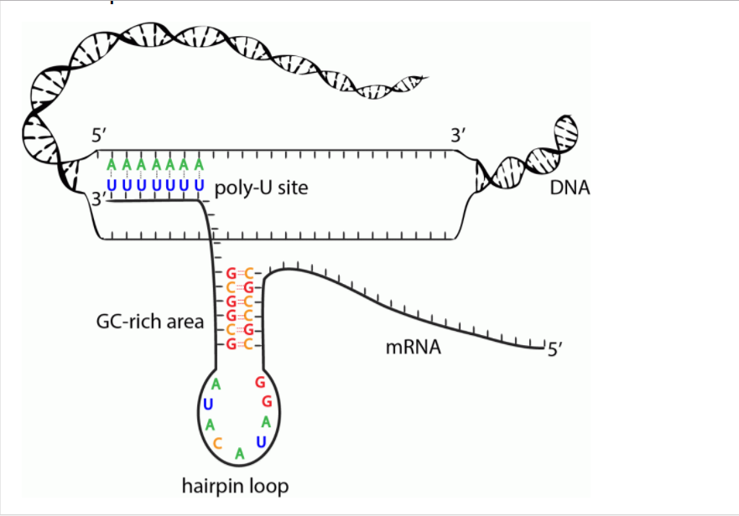
The presence of a hairpin in an RNA transcript causes RNA polymerase to slow down or pause, which creates an opportunity for termination. At the same time The adenine–uracil base pairings (dA::rU) downstream of the hairpin are relatively unstable compared with other base pairings, and the formation of the hairpin may itself destablize the DNA–RNA pairing, causing the RNA molecule to separate from its DNA template.

- Rho dependent termination
Rho-dependent terminators have two features: (1) DNA sequences that produce a pause in transcription; and (2) a DNA sequence that encodes a stretch of RNA upstream of the terminator that lacks any secondary structures. This unstructured RNA serves as binding site for the rho protein, which binds the RNA and moves toward its 3’end, following the RNA polymerase.
When RNA polymerase encounters the terminator, it pauses, allows rho protein to bind to the unstructured portion of RNA. Rho is helicase protein, it uses to unwind the RNA–DNA hybrid in the transcription bubble, bringing an end to transcription.

